Suggested titles:
  - Perceptual difficulty modulates the direction of information flow in familiar face recognition
  - Representational analysis reveals a dynamical information processing for familiar face perception under perceptual uncertainty
  - Dynamics of information flow for familiar face perception under perceptual uncertainty

Abstract
Humans are rapid and accurate in recognizing familiar faces. Previous neurophysiological studies are dominated by the evidence supporting the contribution of feed-forward neural mechanisms, but there are little data on the spatiotemporal dynamics, including feedback, of familiar face processing. We hypothesized that feedback mechanisms should play an essential role as they do in object recognition. We employed an active familiar/unfamiliar face categorization paradigm with variable levels of perceptual difficulty to evoke the contribution of top-down cognitive processes when sensory evidence was not sufficient to support face recognition. We developed a novel multivariate informational connectivity method for electroencephalography (EEG) data to track the categorical face information across peri-frontal and peri-occipital brain areas. This extends previous studies, which showed the domination of bottom-up sensory mechanisms but may have missed the effect of recognition task and perceptual difficulty on activating top-down neural mechanisms. We also employed a spectrum of familiarity levels including famous, self and personally familiar faces, and decoded enhanced representations for more familiar faces in a neural familiarity spectrum. These findings demonstrate the neural networks involved in familiar face recognition, and the conditions needed to evoke their contributions. Our new connectivity method can also be utilized to track predicted aspects of information across the brain on a broad range of cognitive tasks.

Keywords: Face Recognition, Familiar Faces, Multivariate Pattern Analysis (MVPA), Representational Similarity Analysis (RSA), Informational Connectivity

Introduction
Faces are crucial for our social interactions, allowing us to extract information about identity, gender, age, familiarity, intent and emotion. Familiar faces are categorized more quickly and accurately than unfamiliar ones, and this advantage is more pronounced under difficult viewing conditions, where categorizing unfamiliar faces often fails (Ramon and Gobbini, 2018; Young and Burton, 2018). The neural correlates of this behavioral advantage suggest an enhanced representation of familiar over unfamiliar faces in the brain (Dobs et al., 2019; Landi and Freiwald, 2017). Here, we focus on how face familiarity is processed and what neural networks contribute specifically to familiar face recognition.
Recent human studies have compared the neural dynamics for familiar versus unfamiliar face processing (Ambrus et al., 2019; Collins et al., 2018; Dobs et al., 2019). In particular, they have explored the possibility that the face familiarity effect occurs because these faces have been seen repeatedly, which facilitates the flow of information through the occipito-temporal system in a bottom-up feed-forward manner (di Oleggio Castello and Gobbini, 2015; Ellis et al., 1979; Young and Burton, 2018). Alternatively, it maybe that familiar faces have existing representations that facilitate the processing of incoming information through top-down feedback mechanisms (Gobbini and Haxby, 2006; Kramer et al., 2018). Using the high temporal resolution of electroencephalography (EEG) and magnetoencephalography (MEG), the most recent studies have shown that familiarity affects the initial time windows of face processing in the brain, which are generally attributed to the feed-forward mechanisms of the brain (Ambrus et al., 2019; Dobs et al., 2019). We develop novel methods to explore the flow of information in the brain to assess this hypothesis further.
In recent E/MEG studies reporting support for a feed-forward explanation of the face familiarity effect, participants were asked to detect predetermined faces (Ambrus et al., 2019) or find a match between faces in series of consecutively presented faces (Dobs et al., 2019). This makes familiarity irrelevant to the task of the participant. Such indirect (or passive) tasks may reduce the involvement of top-down familiarity-related feedback mechanisms, as was demonstrated in a recent study (Kay et al., 2017). To fully test the contribution of feedback effects to the familiarity effect, therefore, we need active tasks that are affected by familiarity. Moreover, while some univariate event-related potential (ERP) studies have shown amplitude modulation by levels of face familiarity (Henson et al., 2008; Kaufmann et al., 2009; Schweinberger et al., 2002; Huang et al., 2017), others failed to capture familiar face identity information at single-electrode level ERPs, but observed it at the level of multiple electrodes using multivariate pattern analysis (MVPA; (Ambrus et al., 2019)). Therefore, it remains ambiguous whether the observed familiarity effects are outputs of a chain of brain networks or specific to particular brain areas.
Most of the studies mentioned above used celebrity faces. As familiar faces can range widely from celebrity faces to highly familiar ones such as family members, relatives, friends, and even one's own face (Ramon and Gobbini, 2018), these results might not reflect the full "familiarity spectrum", if the brain implements such a spectrum at all. A better understanding of familiar face recognition requires characterizing the computational steps and representations for sub-categories of familiar faces, including personally familiar, visually familiar, famous, and experimentally learned faces. Such face categories might not only differ in terms of their visual representations and their information coding, but also the availability of personal knowledge, relationships, and emotions associated with the identities in question (Ramon and Gobbini, 2018). These categories may, therefore, vary in terms of the potential for top-down influences in the process. To our knowledge, only a few functional magnetic resonance imaging (fMRI) studies have investigated the differences between different types of familiar faces (Ida Gobbini et al., 2004; Landi and Freiwald, 2017; Leibenluft et al., 2004; Ramon et al., 2015; Sugiura et al., 2015; Taylor et al., 2009), and there are no studies that systematically compare the temporal dynamics of information processing for this "familiarity spectrum".
Timing information is crucial in making these comparisons as feed-forward, and feedback information flow often differs in the temporal dynamics. With the advent of informational connectivity methods, we now have the potential to examine the interaction of information between feed-forward and feedback mechanisms to characterize their potential spatiotemporal contribution to familiar face recognition (Goddard et al., 2016; Anzellotti and Coutanche, 2018; Nili et al., 2020). This requires novel methods to track the flow of information from a given brain area to a destination area and link this flow to task goals. Such analyses can provide valuable insights for understanding the neural mechanisms underlying familiar face recognition in humans.
In our study, participants performed a familiar vs. unfamiliar face categorization task on sequences of images selected from four face categories (i.e., unfamiliar, famous, self, and personally familiar faces), with dynamically updating noise patterns, while their EEG data were recorded. By varying the signal-to-noise ratio of each image sequence using perceptual coherence, we were able to investigate how information for the different familiar categories gradually builds up in the electrical activity recordable by scalp electrodes, and how this relates to the amount of sensory evidence available in the stimulus (perceptual difficulty). The manipulation of sensory evidence also allowed us to investigate when, and how, feedback information flow affects familiar face recognition. Using univariate and multivariate pattern analyses, representational similarity analysis (RSA) and a novel informational connectivity analysis method, we reveal the temporal dynamics of neural representations for different levels of face familiarity.
Our results show that self and personally familiar faces lead to higher perceptual categorization accuracy and enhanced representation in the brain even under highly noisy conditions while famous (visually familiar) and unfamiliar face categorization is only possible in high-coherence conditions. Importantly, our novel information flow analysis reveals that in high-coherence conditions, the feed-forward sweep of face category information processing is dominant while at lower coherence levels, the face category information is feedback dominated. Such a gradual change in feedback versus feed-forward dominance as a function of coherence level supports a dynamic exchange of information between higher-order (frontal) cognitive and visual areas depending on the amount of sensory evidence.

Results
We designed a paradigm to study how the stimulus- and decision-related activations for different face categories build up gradually during stimulus presentation and how these built-up activations relate to the amount of sensory evidence. We recorded EEG data from human participants (n=18) while they categorized faces images as familiar or unfamiliar. We also varied the amount of sensory evidence by manipulating the phase coherence of images on different trials (Figure 1A). In each 1.2 secs (max) sequence of image presentation (trial), the pattern of noise changed in each frame while the face image and the overall coherence level remained the same. Familiar face images (120) were equally selected from celebrity faces, participants' own, and personally familiar faces (e.g., friends, family members, relatives) while unfamiliar face images (120) were completely unknown to participants before the experiment. Within each block of trials, familiar and unfamiliar face images with different coherence levels were presented in random order.

Levels of familiarity are reflected in behavioral performance
We quantified our behavioral results using accuracy and reaction times on correct trials. Specifically, accuracy was the proportion of images correctly categorized as either familiar or unfamiliar. All participants performed with high accuracy (> 0.92) at the highest phase coherence (55%), and their accuracy was much lower (~0.62) at the lowest coherence (22%; Figure 1B). The correct reaction times show that participants were faster to categorize the face at high phase coherence levels than lower ones (F(3)=65.797, p<0.001, main effect). We also calculated the accuracy and reaction times for the sub-categories of the familiar category separately (i.e. famous, personally familiar and self). Note that the task was two-alternative forced-choice between familiar vs. unfamiliar faces, so participants were not specifically asked to categorize the sub-categories. The calculated accuracy here is the ratio of correct responses within each of these familiar sub-categories. The results show a gradual increase in accuracy as a function of phase coherence and familiarity (Figure 1D, two-way ANOVA. Bonferroni corrected p-value, factors: coherence level and face category. Face category main effect: F(2)=188.708, p<0.001, coherence main effect: F(3)= 188.708, p<0.001, and interaction: F(6)=12.979, p<0.001), with the highest accuracy in categorizing their own (self), then personally familiar, and finally famous (or visually familiar) faces. The reaction time analysis also showed a similar pattern where participants were fastest to categorize self faces, then personally familiar and famous faces (Figure 1E, two-way ANOVA. Bonferroni corrected p-value, factors: coherence level and face category. Face category main effect: F(2)=174.063, p<0.001, coherence main effect: F(3)= 104.861, p<0.001, and interaction: F(6)=17.051, p<0.001).

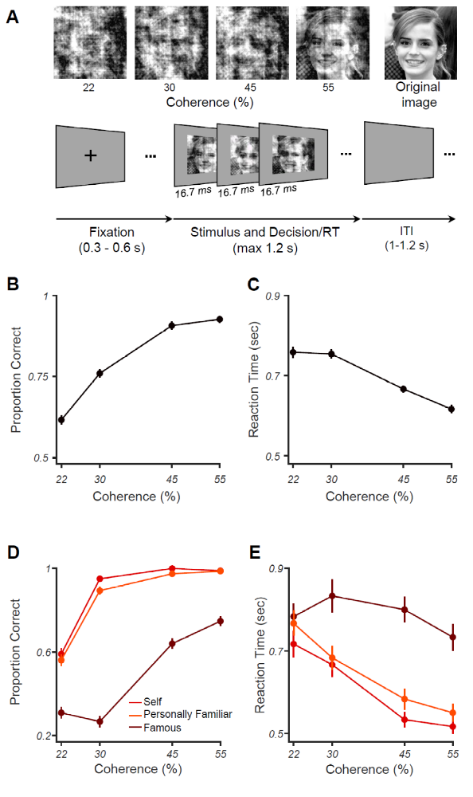
Figure 1. Experimental design and behavioral results for familiar vs. unfamiliar face categorization. (A) Upper row shows a sample face image (from the famous category) at the four different phase coherence levels (22, 30, 45, and 55%) used in this experiment, in addition to the original image (not used). Lower row shows schematic representation of the experimental paradigm. In each trial, a black fixation cross was presented for 300-600 ms (randomly selected). Then, a noisy and rapidly updating (every 16.7 ms) stimulus of a face image (unfamiliar, famous, personally familiar, or self), at one of the four possible phase coherence levels, was presented until response, for a maximum of 1.2 s. Participants had to categorize the stimulus as familiar or unfamiliar by pressing one of two buttons (button mappings counterbalanced over blocks). There was then a variable intertrial interval (ITI) lasting between 1-1.2 s (chosen from a uniform random distribution). (B) Mean accuracy for face categorization, as a function of coherence levels; (C) Median reaction times for the face categorization, as a function of coherence levels. (D) and (E) show the results for different familiar face sub-categories. Error bars in all panels are the standard error of the mean across participants.

Event-related potentials reflect behavioral familiarity effects
Our behavioral results showed that there is a graded increase in participants' performance as a function of familiarity level - i.e., participants achieve higher performance if the faces are more familiar to them. As an initial, more traditional, pass at the data, we explored how the neural responses were modulated by different levels of familiarity and coherence by averaging event-related potentials (ERP) across participants for different familiarity levels and phase coherences (Figure 2B). This is important as recent work failed to capture familiar face identity information from single electrodes (Ambrus et al., 2019). At high coherence, the averaged ERPs, obtained from a centroparietal electrode which is representative of the response, demonstrated an early, category-irrelevant, evoked response, followed by an increase in the amplitude proportional to familiarity levels, showing that self faces elicited the highest ERP amplitude, followed by personally familiar, famous, and unfamiliar faces (Figure 2B for 55% phase coherence). This observation of late differentiation between familiarity levels at later time points seems to support evidence accumulation over time, which is more pronounced at higher coherence levels where the brain had access to reliable information. We also observed a similar pattern between the ERPs of different familiarity levels at the time of decision (just before the response was made). Such differentiation was lacking at the lowest coherence level, where the amount of sensory evidence, and behavioral performance, were low (Figure 2A for 22% phase coherence). These results reveal the neural correlates of perceptual differences in categorizing different familiar face categories under perceptually difficult conditions.
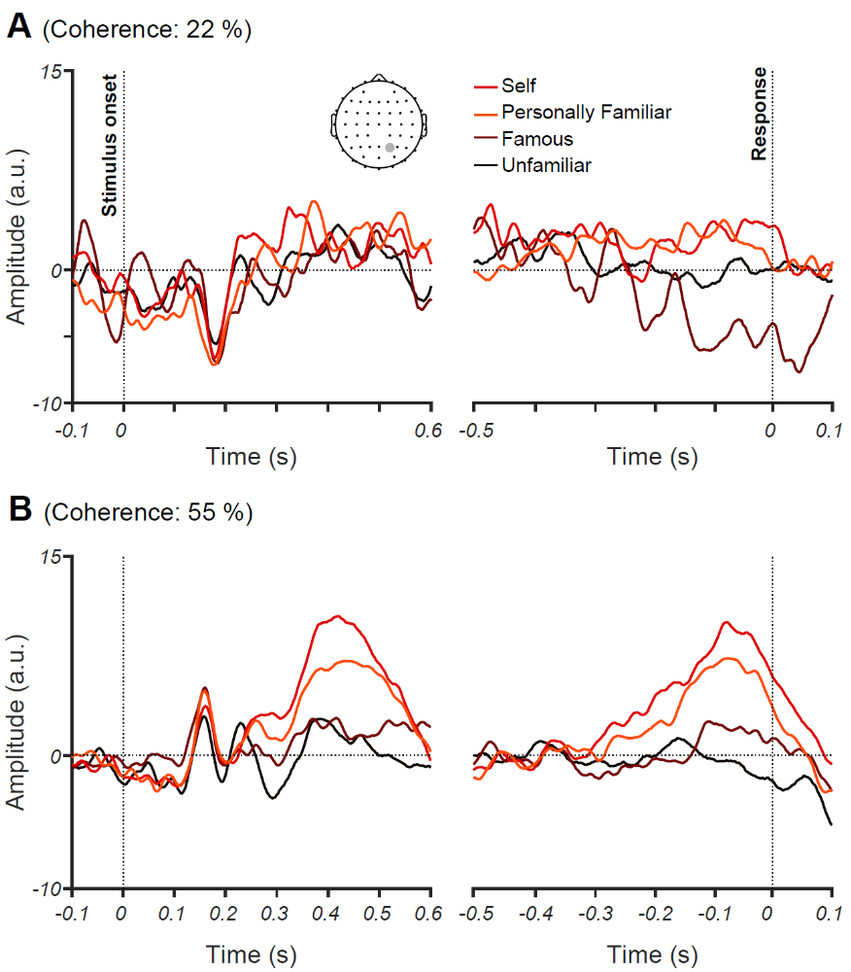
Figure 2. The effect of familiarity and sensory evidence on event-related potentials (ERPs). Averaged ERPs for 22% (A) and 55% (B) phase coherence levels and four face categories across all participants for an electrode at a centroparietal site (CP2). Note that the left panels show stimulus aligned ERPs while the right panel shows response aligned ERPs.

Dynamics of neural representation and evidence accumulation for different face familiarity levels
Our results so far are consistent with previous event-related studies showing that the amplitude of ERPs is modulated by the familiarity of the face (Henson et al., 2008; Kaufmann et al., 2009; Schweinberger et al., 2002; Huang et al., 2017). Our key analyses, however, use multivariate pattern analysis and representational similarity analysis on these EEG data to quantify the time course of familiar vs. unfamiliar face processing. Compared to traditional single-channel (univariate) ERP analysis, MVPA allows us to capture the whole-brain widespread and potentially subtle differences between the activation dynamics of different familiarity levels (Ambrus et al., 2019; Dobs et al., 2019). Specifically, we asked: (1) how the coding dynamics of stimulus- and response-related activities change depending on the level of face familiarity; and (2) how manipulation of sensory evidence (phase coherence) affects neural representation and coding of different familiarity levels.
To obtain the temporal evolution of information across time, we trained the classifier on every time point with 90% of the trials from familiar and unfamiliar datasets and tested them on the 10% left-out portion of data in 10-fold cross-validation (see Methods). Our decoding analysis performed on participants' correct trials showed that, up until ~200 ms after stimulus onset, decoding accuracy is near chance for all coherence levels (Figure 3A). In contrast, decoding accuracy for face identity in previous studies peaked around this time point (Amrus et al., 2019; Dobs et al., 2019). The decoding accuracy then gradually increases over time and peaks around 500ms post-stimulus for the highest coherence level (55%) but remains around chance for the lower coherence level (22%, Figure 3A). The accuracy for intermediate coherence levels (30% and 45%) falls between these two bounds but only reaches significance above chance for the 45% coherence level. This ramping up temporal profile suggests an accumulation of sensory evidence in the brain across the time course of stimulus presentation.
To examine if neural responses can be decoded at finer categorization levels, we separately calculated the decoding accuracy for each of the familiar face sub-categories (after collapsing the data across all coherence levels and decoding familiar vs. unfamiliar trials as explained above): unfamiliar, famous, self and personally familiar faces (Figure 3B). The decoding accuracy was highest for self faces, both for stimulus- and response-aligned analyses, followed by personally familiar, famous and unfamiliar faces. Accuracy for the response-aligned analysis shows that the decoding gradually increased to peak decoding ~100 ms before the response was given by participants. This temporal evolution of decoding accuracy is indicative of an evidence accumulation process which begins after early visual perception and has a processing time that depends on the strength of the sensory evidence (Hanks and Summerfield, 2017; Philiastides et al., 2006).
To determine whether the neural dynamics and decoding accuracy during stimulus presentation prior to response are indeed associated with the perceptual task, as captured by our participants' behavioral performance, we calculated the correlation between decoding accuracy and perceptual performance. The correlation was calculated between 16 data points from decoding accuracy and their corresponding behavioral accuracy rates (4 face categories * 4 phase coherence levels), collapsed over participants. The correlation peaked ~500 ms post-stimulus (Figure 3C), which is just before the response was given. This is consistent with an evidence accumulation mechanism aiming at deciding whether to press the button for 'familiar' or 'unfamiliar', which took another ~100 ms to turn into action (finger movement).

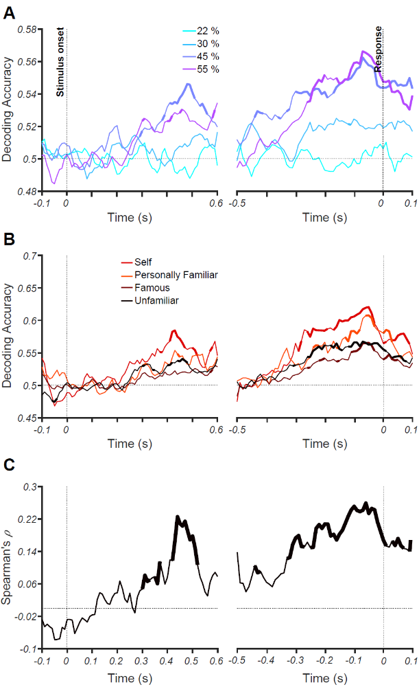
Figure 3. Decoding of face familiarity from EEG signals. (A) Time course of decoding accuracy for familiar versus unfamiliar faces from EEG signals for four different phase coherence levels (22%, 30%, 45%, and 55%). (B) Time course of decoding accuracy for four face categories (i.e., unfamiliar, famous, self and personally familiar faces) from EEG signals collapsed over phase coherence levels. The chance accuracy is 0.5. Thickened lines indicate the time points when the accuracy was significantly above chance level (sign rank test, FDR corrected across time, p<0.05). (C) Correlation between behavioral performance and decoding accuracy (across all conditions) over time. Thickened lines indicate the time points when the correlation was significant. The left panels show the results for stimulus-aligned analysis while the right panels show the results for response-aligned analysis (averaged over 18 participants).

Low-level stimulus differences between conditions could potentially drive the differences between categories (e.g., self faces being more frontal than famous faces, leading to brighter images and therefore the separability of self from frontal faces). To address such potential differences, we carried out a supplementary analysis using RSA (Dobs et al., 2019; Ambrus et al., 2019). We did equalize the frequency content, pixel intensities and contrast of the images of our dataset, but we can see if there are other low-level differences by creating a model representational dissimilarity matrix (RDM) for each of the categories under different phrase coherences. Briefly, neural RDMs are constructed by calculating the correlations (or dissimilarities) of the brain response to different face stimuli to give an abstract representation of information encoding in the brain. Model RDMs reflect our predicted representations in the brain (see Methods). The model RDMs were created for discriminating familiar from unfamiliar (Figure 4A) and also the sub-category familiarity levels (Figure 4B). We then computed partial Spearman's correlations between the corresponding model and neural RDMs for every time point and participant, while partialling out (Figure 4)/not partialling out (Supplementary Figure 1) low-level feature model RDM .
This analysis revealed the emergence of categorical representation for high-level categories (familiar vs. unfamiliar faces) at around 270 ms post-stimulus for the highest coherence level (55%, Figure 4A). The onset of significant representation is slightly later for lower coherence levels (e.g., 45%, Figure 4A), which may suggest the need for additional processing time to evaluate the sensory evidence before decision making. Although the sub-category familiarity dynamics also show gradual accumulation of information (Figure 4B), especially for the 45% and 55% coherence, they are not as clear as when considering the familiar-unfamiliar model (Figure 4A). This might be because the familiar-unfamiliar model not only captures information about stimulus categories (being familiar vs. unfamiliar), but it also captures the participants' task (decision and response), which is a familiar/unfamiliar categorization. Although the task information contributes to the sub-category familiarity model too, in the familiar-unfamiliar model, it completely matches, which might be a reason for the less noisy representation. Apart from a small difference in absolute decoding rates, the dynamics of neural representations were similar when not partialling out the low-level feature model RDM (Supplementary Figure 1), presenting the ramping up of information, with earlier and most mounting trends for highest coherence levels (i.e. 45% and 55%). The similar patterns of neural information decoding between the correlation patterns with and without the low-level feature model suggest that low-level image statistics may only play a minor role in driving the observed decoding analyses. In all the following RSA-based analyses, however, we partialled out the low-level feature model to avoid their potential contribution to the results.
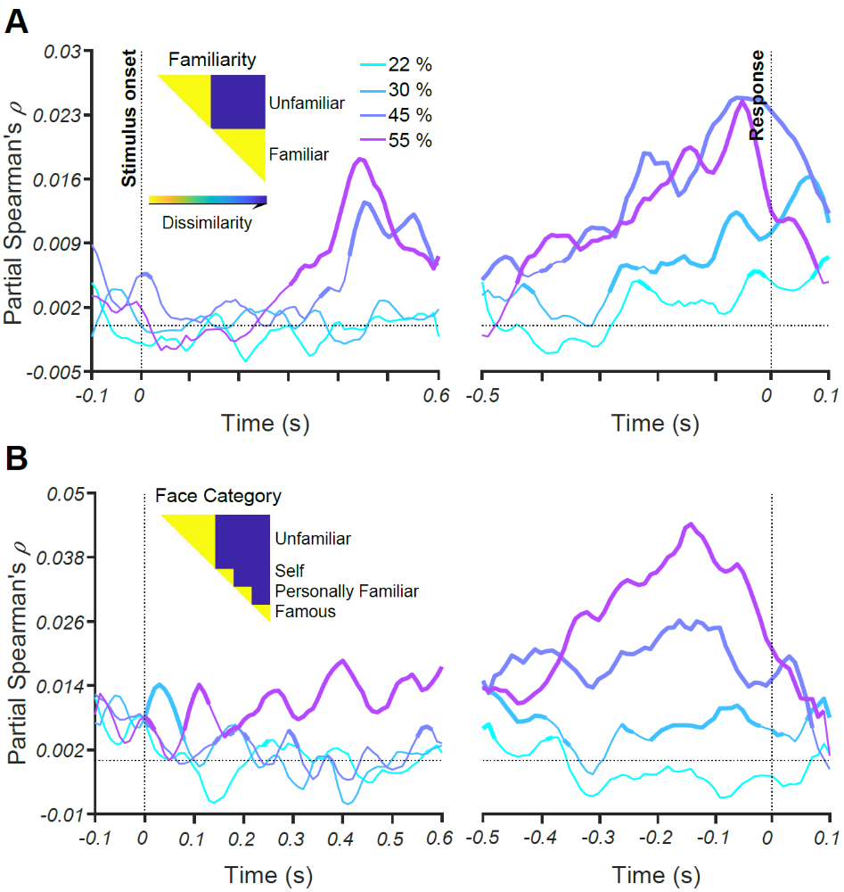
Figure 4. Representations of face familiarity and categories revealed by RSA. Time course of partial Spearman's correlations between neural RDMs and model RDM (shown as insets) for (A) face familiarity; and (B) face categories, unfamiliar, famous, personally familiar and self faces, after partialling out contributions from low-level features (see Methods). Each colored trace shows the correlations over time for one phase coherence level. Thickened lines indicate time points where the correlation is significant (sign permutation test, FDR-corrected significance level at p < 0.05), and black horizontal dotted lines indicate 0 correlation. The left panels show the results for stimulus aligned analysis while the right panels represent the results for response-aligned analysis.

Task difficulty and familiarity level affect information flow across the brain
Next, we investigated how the dynamics of feed-forward and feedback information flow changes during the accumulation of sensory evidence and the evolution over a trial of neural representations of face images. Combining RSA and a novel Granger causality-based connectivity method, we quantified the relationships between the evolution of information based on peri-occipital EEG electrodes and those of the peri-frontal electrodes. Briefly, feed-forward information flow is quantified as the degree to which the information from peri-occipital electrodes contributes to the information recorded at peri-frontal electrodes at a later time point, which reflects moving the frontal representation closer to that required for task goals. Feedback flow is defined as the opposite: the contribution to information at peri-frontal electrodes to that recorded later at peri-occipital electrodes (Figure 5A).
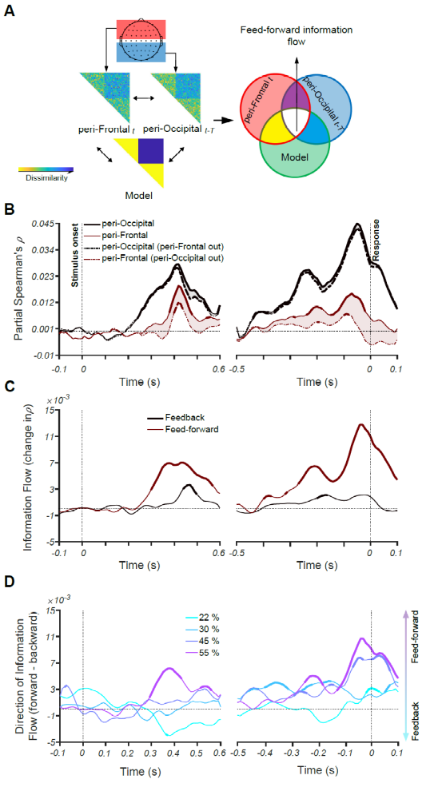
Figure 5. Feed-forward and feedback information flow revealed by RSA. (A) A schematic presentation of the method for calculating Granger causal connectivity between the peri-frontal and peri-occipital electrodes, termed feed-forward and feedback information flow. Feed-forward information flow is calculated as the correlation between the present peri-frontal neural RDM and the predicted model RDM minus the same correlation when the earlier peri-occipital neural RDM is partialled out from it. (B) Time course of partial Spearman's correlations representing the partial correlations between the peri-occipital (black) and peri-frontal (brown) EEG electrodes and the model (see the inset in A) while including (solid) and excluding (dashed) the effect of the other area at phase coherence of 55%. The shaded area shows the decline in partial correlation of the current area with the model after excluding (partialling out) the RDM of the other area. Note that in both the dashed and solid lines, the low-level image statistics are partialled out of the correlations, so we call them partial in both cases. (C) Feedforward (brown) and feedback (black) information flows obtained by calculating the value of the shaded areas in the corresponding curves in B. (D) Direction of information flow for different coherence levels, determined as the difference between feed-forward and feedback information flow showed in C. Thickened lines indicate time points at which the difference is significantly different from zero (sign permutation test and corrected significance level at p < 0.05), and black dotted lines indicate 0 correlation. The left panels show the results for stimulus aligned analysis while the right panels represent the results for response-aligned analysis.

The results show that at the highest coherence level (55%, Figure 5B), information flow is dominantly in the feed-forward direction. This is illustrated by the shaded area in Figure 5B where partialling out the peri-frontal from peri-occipital correlations only marginally reduces the total peri-occipital correlation (Figure 5B, black curves and shaded area), meaning that there is limited information transformation from peri-frontal to peri-occipital. In contrast, partialling out the peri-occipital from peri-frontal correlations leads to a significant reduction in peri-frontal correlation, meaning that much of the peri-frontal is feed-forward (Figure 5B, brown curves and shaded area). This trend is also seen for response-aligned analysis.
These differences are better represented in Figure 5C where the peaks of feed-forward and feedback curves show that the feed-forward information is dominant earlier, followed by feedback information flow, as shown by the later peak of feedback dynamics. These results suggest that when the sensory evidence is high, feed-forward information flow may be sufficient for categorical representation and decision making while feedback only slightly enhances the representation. However, in lower coherence levels (i.e., low sensory evidence), the direction of information is dominantly feedback (Figure 5D). Here, we can see that the lower sensory evidence correlates with more engagement of feedback mechanisms, suggesting that feedback is recruited to boost task-relevant information in sensory areas under circumstances where the input is weak. Overall, our systematic manipulation of the strength of sensory evidence using phase coherence imposed a range of perceptual difficulty, which ultimately affects the dynamics and contribution of feedback and feed-forward mechanisms in the brain.
Importantly, as shown in Figure 4, the model used in Figure 5A contains both the information about familiarity and information about the participant's decision and response. This might contribute to the observed feedback information in the low coherence (22%) condition. To reduce the influence of decision and response factors and examine whether the flow of information varies based only on levels of face familiarity (i.e., unfamiliar, famous, personally familiar and self), we also tested other sets of models targeting the flow of information specific to individual categories (Figure 6). As the results show, when the data are aligned to stimulus onset, self faces show the highest amount of feed-forward flow of information starting to accumulate after the stimulus onset, reaching significance ~500 ms. However, less familiar categories do not reach significance. In the response-aligned analysis, again, there are only significant time points showing a feed-forward flow for the self face category. These results suggest that while the information about the three familiarity levels might be processed by the neural mechanisms of the feed-forward visual stream, only the familiarity information in the self face category is reliable enough to be captured by our connectivity analysis method.
Altogether, the results of information connectivity analysis suggest that in familiar face recognition, both top-down and bottom-up mechanisms play a role, with the amount of sensory evidence playing an important role in determining their relative contribution. It also suggests that the degree to which sensory information is processed feed-forward can be modulated by the familiarity level of the stimulus.

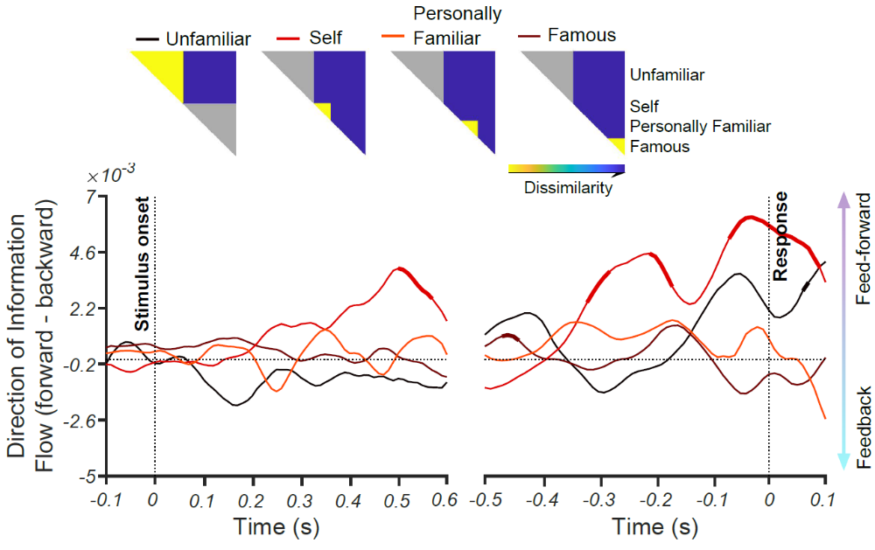
Figure 6. Directions of information flow for different familiarity levels using their corresponding RDM models. The models, as depicted on the top, are constructed so that they measure how much, and with what temporal dynamics the information about each face categories move between the peri-occipital and peri-occipital brain areas. The yellow areas in the models refer to the target category (including unfamiliar, famous, self and personally familiar faces) and the gray areas reflect the representations which were not used in the calculation of partial correlations. Thickened lines indicate time points at which the difference is significantly different from zero (sign permutation test and corrected significance level at p < 0.05), and black horizontal dotted lines indicate 0 correlation. The left panel shows the result for stimulus-aligned analysis while the right panels represent the result for response-aligned analysis.

Discussion
This study investigated the neural mechanisms of familiar face recognition to determine how perceptual difficulty and levels of familiarity affect face processing, specifically addressing the contribution of feed-forward and feedback processes. In a familiar/unfamiliar face categorization task, we showed that manipulating the strength of the available sensory evidence and/or familiarity affected the informational content of neural responses about face category. We were able to document the neural correlates for a large body of behavioral literature showing an advantage of familiar over unfamiliar face processing in the brain. We developed novel informational connectivity analyses to track the flow of information from peri-occipital to peri-frontal and vice versa. Our results show, for the first time, that when the perceptual difficulty is low (high sensory evidence), the categorical face information is predominantly streamed through feed-forward mechanisms. On the other hand, the flow of categorical face information is predominantly fed back when the perceptual difficulty is high (low sensory evidence). Moreover, only the most familiar face category, the self faces, could evoke the feed-forward flow of information, as captured by our connectivity method.
Our results are consistent with an extant literature suggesting that visual perception comprise both feed-forward and feedback neural mechanisms (Lamme and Roelfsema, 2000; Super et al., 2001; Ress et al., 2000; Lamme et al., 2002; Pratte et al., 2013; Fenske et al., 2006; Lee and Mumford, 2003; Felleman et al., 1991; Summerfield et al., 2006; Delorme et al., 2004). However, previous experimental paradigms and analyses were not able to dissociate feedback and feed-forward information flow in familiar face recognition. This is important since stimulus familiarity, such as other factors including levels of categorization (superordinate vs. basic level; Besson et al., 2017; Praß et al., 2013), task difficulty (Chen et al., 2008; Woolgar et al., 2015; Kay et al., 2017) and perceptual difficulty (Fan et al., 2020; Hupe et al., 1998; Gilbert and Li, 2013; Gilbert and Sigman, 2007; Lamme and Roelfsema, 2000), may affect the complex interplay of feed-forward and feedback information in the brain. Our findings support the description of object recognition as involving a bidirectional feed-forward/feedback flow of information (Bar et al., 2006; Kietzmann et al., 2019; Mohsenzadeh et al., 2018; Karimi-Rouzbahani et al., 2017a; Karimi-Rouzbahani et al., 2017b; Karimi-Rouzbahani et al., 2019), with the key finding that the contribution of feedback may be inversely proportional to the amount of sensory evidence about the stimulus. Specifically, the increase in feedback information may provide some initial guesses, when encountered with noisy stimuli.
We only observed feedback when the sensory evidence was low (high perceptual difficulty) for the most familiar faces. This is consistent with electrophysiological studies in animals that show cortical feedback projections modulate early visual responses when sensory information is low. For example, previous human studies observed increased activity in lower visual areas when the cognitive and perceptual tasks were difficult relative to easy, which the authors attributed to top-down contributions (Ress et al., 2000; Kay et al., 2017). However, due to the low temporal resolution of fMRI, these studies cannot show the temporal evolution of these top-down contributions or the validity of the hypothesized direction. Importantly, the observed increase in activity in lower visual areas does not necessarily correspond to the enhancement of neural representations in those areas - increased univariate signal does not show whether there is better / more information that will support performance. Electrophysiological studies in animals have also shown that cortical feedback projections robustly modulate responses of early visual areas when sensory evidence is low, or the stimulus is difficult to segregate from the background figure (Hupe et al., 1998). A recent study has also found cortical feedback modulated the activity of neurons in the dorsolateral geniculate nucleus (dLGN), which was less consistent when using simple vs. complex grating stimuli (Spacek et al., 2019). Varying perceptual difficulty seems to engage different networks and processing mechanisms: less difficult stimuli such as our high-coherence faces seem to be predominantly processed by the feed-forward mechanisms, while more difficult stimuli such as the low-coherence faces recruit both feed-forward and feedback mechanisms.
We also found that the direction of information flow is influenced by the familiarity of the stimulus. Self and personally familiar faces were predominantly processed through feed-forward mechanisms, which was not the case for the other less-familiar categories. This is consistent with enhanced representations of more familiar face categories in the feed-forward pathways (Dobs et al., 2019; di Oleggio Castello and Gobbini, 2015; Ellis et al., 1979; Young and Burton, 2018), which then, in turn, requires less top-down contributions to facilitate the perception of relevant information (Bar et al., 2006; Gilbert and Sigman, 2007). Our results might initially seem inconsistent with Fan et al. 's (2020) study, which did not report significant differences between the temporal dynamics of familiar and unfamiliar face representations; however, they only used famous faces within the familiar face category. In our sub-category analysis, we also did not observe differences between famous faces and unfamiliar faces; our main findings were from highly familiar faces (self and personally familiar). Overall, then, our results suggest that processing of highly familiar faces is dominated by feed-forward information flow.
The RSA-based connectivity method proposed in this study further develops a recent shift towards multivariate brain connectivity methods (Anzellotti and Coutanche, 2018; Nili et al., 2020; Keitzmann et al., 2019; Goddard et al., 2016; Karimi-Rouzbahani, 2018; Karimi-Rouzbahani et al., 2019; Clarke et al., 2018), and introduces several advantages over previous methods of connectivity analyses. These methods examine inter-area interactions through indirect measures of connectivity such as gamma-band synchronization (Gregoriou et al., 2009), shifting power (Bar et al., 2006) or causality in the activity patterns (Summerfield et al., 2006; Fan et al., 2020). Such traditional brain connectivity methods consider simultaneous (or time-shifted) correlated activations of different brain areas as connectivity, but they are unable to examine how (if at all) relevant information is transferred across those areas. Goddard et al. (2016) developed an RSA-based connectivity method to solve these issues, which allowed us and others to track the millisecond transfer of object category information across peri-frontal and peri-occipital brain areas (Karimi-Rouzbahani, 2018; Karimi-Rouzbahani et al., 2019; Keitzmann et al., 2019). This method, however, has the limitation that, it cannot tell us what aspects of the representation are transferred and modulated. In other words, we need new methods to tell if the transferred information is contributing to or impairing representations in the destination area. To address this issue, Clarke et al., (2018), proposed an RSA-based informational connectivity method which incorporated RDM models, such as the ones that we used here, to track specific aspects of the transferred information. However, their method did not inform us of the temporal dynamics of information flow across brain areas. Our novel connectivity analysis method allowed, for the first time, to explicitly determine the content, the direction and the temporal evolution of the information transferred from the peri-frontal to peri-occipital areas and vice versa. The relevance of the transferred information is determined by the amount that the representations in the destination area are shifted towards our predefined predicted RDM models. In this way, we could determine the temporal dynamics of the contributory element of the transferred information. This informational connectivity method is an MVPA-based method and can be used to address any questions about human cognition using a variety of multivariate brain imaging modalities.
Our MVPA results provided neural correlates for the behavioral advantage in recognizing more vs. less familiar faces in a familiarity spectrum for the first time. As in previous studies, our participants were better able to categorize highly familiar than famous or unfamiliar faces, especially in low-coherence conditions (Kramer et al., 2018; Young and Burton, 2018). This behavioral advantage can be a result of long-term exposure to variations of personally familiar faces under different lighting conditions and perspectives, which is usually not the case for famous faces. Importantly, our neural decoding results provided quantified neural representational advantage for more familiar faces compared to less familiar ones (i.e. higher decoding for the former than the latter) to suggest that more familiar faces lead to more distinguishable neural representations as well. Decoding accuracy was also proportional to the amount of sensory evidence: the higher the coherence levels, the higher the decoding accuracy. We observed that the decoding accuracy "ramped-up" and reached its maximum ~100 ms before participants' expressed their decisions (key press). These results provide direct evidence for sensory evidence accumulation and decision making processes during face processing in humans, consistent with previously reported data in monkey and recent single-trial ERP studies (Kelly et al., 2013; Hanks and Summerfield, 2017; Philiastides et al., 2006; Philiastides and Sajda, 2006; Shadlen and Newsome, 2001). The significant correlation between MVPA and our behavioral results showed, for the first time, a direct relationship between neural representation and behavioral outcomes with regard to familiar face processing. This means that the behavioral advantages of self faces and the condition with the highest sensory evidence (highest coherence) were probably driven by the enhanced neural representations in those conditions.
Many studies show that face familiarity modulation of early ERP components such as N170, N250, and P300 (Dobs et al., 2019; Ambrus, 2019; Fan et al., 2020; Henson et al., 2008; Kaufmann et al., 2009; Schweinberger et al., 2002; Huang et al., 2017), which may seem in contrast to our results. Typically, these studies use event-related paradigms with faces presented for extended periods (>200ms). This can bias towards domination of feed-forward processing (Goddard et al., 2016; Karimi-Rouzbahani, 2018), because of the co-processing of the incoming sensory information and the recurrence of earlier windows of the same input (Kietzmann et al., 2019; Mohsenzadeh et al., 2018), making it hard to measure feedback. Our dynamic masking paradigm avoids this and also slows down the process of evidence accumulation so that it became more trackable in time.
In conclusion, our study showed that the processing of face information involves both feed-forward and feedback flow of information in the brain, and which predominates depends on the strength of incoming perceptual evidence and the familiarity of the face stimulus. To do that, we developed novel connectivity analysis methods to disentangle feed-forward and feedback contributions to the advantage of familiar over unfamiliar faces in human perception. This connectivity method can be applied to study a wide range of cognitive processes, wherever information is represented in the brain and transferred across areas. We also showed for the first time that the behavioral advantage for familiar face processing is robustly reflected in neural representations of familiar faces in the brain and can be quantified using multivariate pattern analyses. These new findings and methods open new avenues for exploring object recognition in general, and the impact of different behavioral tasks on the direction of information flow in the brain.

Materials and Methods

Participants
We recorded from 18 participants (15 male, aged between 20-26 years, all with normal or corrected-to-normal vision). Participants were students from the Faculty of Mathematics and Computer Science at the University of Tehran, Iran. All participants voluntarily participated in the experiments and gave their written consent prior to participation. All experimental protocols were approved by the ethical committee of the University of Tehran. All experiments were carried out in accordance with the guidelines of the Declaration of Helsinki.

Stimuli
We presented face images of four categories, including unfamiliar, famous, self and personally familiar faces. The unfamiliar faces (n=120) were unknown to participants. The famous faces (n=40) were pictures of celebrities, politicians, and other well-known people. These faces were selected from different, publicly available face databases. In both categories, half of the images were female, and half were male. To ensure that all participants knew the famous face identities, participants completed a screening task prior to the study. In this screening, we presented them with the names of famous people in our data set and asked if they were familiar with the person.
The personally familiar faces were selected from participants' family, close relatives, and friends (n=40); self-images were photographs of participants (n=40). The images of self and personally familiar faces were selected to have varied backgrounds and appearances. On average, we collected n=45 for personally familiar and n=45 for self faces for every individual participant. All images were cropped to have 400×400 pixels and were converted to greyscale (Figure 1A). We ensured that spatial frequency, luminance, and contrast were equalized across all images. The magnitude spectrum of each image was adjusted to the average magnitude spectrum of all images in our database .
The phase spectrum was manipulated to generate noisy images characterized by their percentage phase coherence (Dakin et al., 2002). We used a total of four different phase coherence values (22%, 30%, 45%, and 55%), chosen based on behavioral pilot experiments, so overall behavioral performance spanned the psychophysical dynamic range. Specifically, the participants scored 52.1%, 64.7%, 85.2% and 98.7% in the mentioned coherence levels in the piloting. At each of the four phase coherence levels, we generated multiple frames for every image: the number of frames generated depended on the reaction time of the participants, as explained below.

EEG acquisition and Apparatus
We recorded EEG data from participants while they were performing the face categorization task. EEG data were acquired in an electrostatically shielded room using an ANT Neuro Amplifier (eego 64 EE-225) from 64 Ag/AgCl scalp electrodes and from three periocular electrodes placed below the left eye and at the left and right outer canthi. All channels were referenced to the left mastoid with input impedance <15k and chin ground. Data were sampled at 1000 Hz and a software-based 0.1-200 Hz bandpass filter was used to remove DC drifts, and high-frequency noise and 50 and 100 Hz (harmonic) notch filters were applied to minimize line noise. These filters were applied non-causally (using MATLAB filtfilt) to avoid phase-related distortions. We used Independent Component Analysis (ICA) to remove artefactual components in the signal. The components which were reflecting artefactual signals (eye movements, head movements) were removed based on ADJUST's criteria (Mognon et al., 2011). Next, trials with strong eye movement or other movement artifacts were removed using visual inspection. On average, we kept 98.74%±1.5% artifact-free trials for any given condition.
We presented images on LCD monitor (BenQ XL2430, 24", 144 Hz refresh rate, resolution of 1920 ×1080 pixels) and the stimulus presentation was controlled using custom-designed MATLAB codes and Psychtoolbox 3.0 (Brainard, 1997; Pelli, 1997). We presented stimuli at a distance of 60 cm to the participant, and each image subtended 8° × 8° of visual angle.

Procedure
Participants performed a familiar vs. unfamiliar face categorization task by categorizing dynamically updating sequences of either familiar or unfamiliar face images in two recording sessions (Figure 1A). Image sequences were presented in rapid serial visual presentation (RSVP) fashion at a frame rate of 60 Hz frames per second (i.e.,16.67 ms per frame without gaps). Each trial consisted of a single sequence of up to 1.2 seconds (until response) with a series of images from the same stimulus (i.e., selection from either familiar or unfamiliar face categories) at one of the four possible phase coherence levels. Importantly, within each phase coherence level, the overall amount of noise remained unchanged, whereas the spatial distribution of the noise varied across individual frames such that different parts of the underlying image was revealed sequentially. If stimuli are presented statically for more than ~200ms, this would result in a dominant feed-forward flow of information simply due to the incoming information (Goddard et al., 2016; Karimi-Rouzbahani, 2019; Lamme et al., 2000). On the other hand, if we present stimuli for very brief durations (e.g. < 50 ms), there may be insufficient time to evoke familiarity processing.
We instructed participants to fixate at the center of the monitor and respond as accurately and quickly as possible by pressing one of two keyboard keys (left and right arrow keys) to identify the image as familiar or unfamiliar using the right index and middle fingers, respectively (the response key counterbalanced). As soon as a response was given, the RSVP sequence stopped, followed by an inter-trial interval of 1–1.2 s (random with uniform distribution). The maximum time for the RSVP sequence was 1.2 secs. If participants failed to respond within the 1.2 secs period, the trial was marked as a no-choice trial and was excluded from further analysis. We had a total of 240 trials (i.e., 30 trials per perceptual category, familiar and unfamiliar, each at four phase coherence levels) during the experiment. We presented six blocks of 36 trials each, and one block of 24 trials and participants had some resting time between the blocks. Each image from the image set was presented to the participants once in each session.

Analysis

Decoding (MVPA) analysis
We decoded the information content of our conditions using Multivariate Pattern Analysis (MVPA) methods with Support Vector Machine (SVM) classifiers (Cortes et al., 1995). MVPA utilizes within-condition similarity of trials and their cross-condition dissimilarity to determine the information content of individual conditions. We trained an SVM classifier on the patterns of brain activity (from 64 EEG electrodes) from 90% of familiar (including personally familiar, famous, and self categories) and 90% of unfamiliar trials, and then tested the trained classifier on the left-out 10% of trials from each category. The classification accuracy from categorization of the testing data shows whether there is information about familiarity in the neural signal. We only used the trials in which the participant correctly categorized the stimulus as familiar or unfamiliar. We repeated this procedure iteratively 10 times until all trials from the two categories were used in the testing of the classifier once (no trial was included both in the training and testing sets in a single run), hence 10-fold cross-validation, and averaged the classification accuracy across the 10 validation runs. To obtain the decoding accuracy through time, we down-sampled the EEG signals to 100 Hz and repeated the same classification procedure for every 10 ms time point from -100 to 600 ms relative to the onset of the stimulus, and from -500 to 100 ms relative to the response. This allowed us to assess the evolution of face familiarity information relative to the stimulus onset and response separately.
To investigate the potential differences in the temporal evolution of the sub-categories contained in the familiar category (i.e., famous, personally familiar and self), we additionally calculated the decoding accuracy for each sub-category separately. Note that, the same decoding results obtained from decoding of familiar vs. unfamiliar categories were used here, only calculated separately for each sub-category of familiar faces.
We used random bootstrapping testing to evaluate the significance of the decoding values at every time point. This involved randomizing the labels of the familiar and unfamiliar trials 10,000 times and obtaining 10,000 decoding values using the above procedure. The p-values of the true decoding values were obtained as [1- p(randomly generated decoding values which were surpassed by the corresponding true decoding value)]. We then corrected the p values for multiple comparisons across time (using MATLAB's mafdr function). After the correction, the true decoding values with p < 0.05 were considered significantly above chance (e.g., 50%).

Brain-behavior correlation
To investigate if the decoding results could explain the observed behavioral face categorization results, we calculated the correlation between the decoding and the behavioral results using Spearman's rank correlation. We calculated the correlation between a 16-element vector containing the proportion correct behavioral responses for the four coherence levels of the four familiarity levels (i.e. Familiar, Famous, Self and Unfamiliar), and another vector with the same structure containing the decoding values from the same conditions at every time point separately. Please note that here we calculated the proportion correct for familiar and unfamiliar sub-categories in contrast to what we did when plotting the behavioral accuracy for the whole experiment in Figure 1B. To determine the significance of the correlations, the same bootstrapping procedure as described above was repeated at every time point by generating 10,000 random correlations after shuffling the elements of the behavioral vector. The true correlations were compared with the randomly generated correlations and deemed significant if their p-values (as computed above) were < 0.05 after correction for multiple comparisons.

Representational similarity analysis
Representational similarity analysis is used here for three purposes. First, to partial out the possible contributions of low-level image statistics to our decoding results, which is not directly possible in the decoding analysis. Second, to investigate possible coding strategies that the brain might have adopted which can explain our decoding, specifically, whether the brain was coding familiar versus unfamiliar faces, the different levels of familiarity or a combination of the superordinate and subordinate categories. Third, to measure the contribution of information from other brain areas to the representations of each given area (see Information flow analysis).
We constructed neural representational dissimilarity matrices (RDMs) by calculating the (Spearman's rank) correlation between every possible representation obtained from every single presented image leading to a 240 by 240 RDM matrix. The matrices were constructed using signals from the electrodes over the whole brain as well as from peri-occipital and peri-frontal electrodes separately as explained later (Figures 4-6). We also constructed image RDMs for which we calculated the correlations between every possible pair of images which had generated the corresponding neural representations used in the neural RDMs. Finally, to evaluate how much the neural RDMs coded the familiar vs. unfamiliar faces and/or different familiarity levels, we constructed two models RDMs. In the Familiar-Unfamiliar model RDM, the elements which corresponded to the correlations of familiar with familiar, or unfamiliar with unfamiliar, representations (and not their cross-correlations) were valued as 1, and the elements which corresponded to the cross-correlations between familiar and unfamiliar faces were valued as 0. The Familiarity level model, on the other hand, was filled with 0s (instead of 1s) for the representations which corresponded to the cross-correlations between different sub-categories of familiar faces (e.g. personally familiar vs. famous) with everything else being the same as the Familiar-Unfamiliar model RDM. To correlate the RDMs, we selected and reshaped the upper triangular elements of the RDMs (excluding the diagonal elements) into vectors called 'RDV'. To evaluate the correlation between the neural RDVs and the model RDVs, we used Spearman's partial correlation in which we calculated the correlation between the neural and the model RDV while partialling out the image RDV as in equation (1):

$∂correlation\left(t\right)=⍴{RDV}_{Neural}\left(t\right){RDV}_{Model}.{RDV}_{Image}.$ (1)

As indicated in the equation, the partial correlation was calculated for every time point of the neural data (10 ms time steps), relative to the stimulus onset and response separately using the time-invariant model and image RDVs. To evaluate the significance of the partial correlations, we used a similar bootstrapping procedure as was used in decoding. However, here we randomized the elements of the model RDV 10,000 times (while keeping the number of ones and zeros equal to the original RDV) and calculated 10,000 random partial correlations. Finally, we compared the true partial correlation at every time point with the randomly generated partial correlations for the same time point and deemed it significant if it exceeded 95% of the random correlations (p < 0.05) after correcting for multiple comparisons.

Information flow analysis
We developed a novel model-based method of information flow analysis to investigate how earlier information content of other brain areas contributes to the present-time information content of a given area. While several recent approaches have suggested for information flow analysis in the brain (Goddard et al., 2016; Karimi-Rouzbahani, 2018; Karimi-Rouzbahani et al., 2019), following the recent needs for these approaches in answering neuroscience questions (Anzellotti and Coutanche, 2018), none of the previously developed methods could answer the question of whether the transferred information was improving the representation of the target area in line with the behavioral task demands. Our proposed model, however, explicitly incorporates the behavioral goals in its formulation and allows us to measure if the representations of target areas are shifted towards the task goals by the received information. An alternative would be that the incoming information from other areas are just epiphenomenal and are task-irrelevant. This new method can distinguish these alternatives.
The model is a particular case of Granger causality which suggests that signal X is said to Granger cause signal Y if the inclusion of past samples of X in the prediction of present samples of Y improves the prediction of present samples of Y, compared to predicting Y using earlier samples of Y alone. Accordingly, we split the EEG electrodes in two groups, each with 16 electrodes: peri-frontal and peri-occipital (Figure 5A) to see how familiarity information is (if at all) transferred between these areas that can be broadly categorized as "cognitive" and "sensory" brain areas, respectively. We calculated the neural RDMs for each area separately and calculated the correlation between the neural RDV and the model RDV, partialling out the image RDM from the correlation (as explained in equation (1)). This resulted in a curve when calculating the partial correlation at every time point in 10 ms intervals (see the solid lines in Figure 5B). Note that the partial correlation curve for the peri-frontal area could have received contributions from the present and earlier representations of the same area (i.e., the latter being imposed by our sequential stimulus presentation). It could also have received contributions from earlier peri-occipital representations through information flow from peri-occipital to the peri-frontal area. To measure this potential contribution, we partialled out the earlier peri-occipital representations in calculation of the partial correlation between peri-frontal and model RDVs according to equation (2):

$Peri-frontal∂correlation\left(t\right)=⍴{RDV}_{Neural}\left(frontal,t\right){RDV}_{Model}.\{{RDV}_{Image},{RDV}_{Neural}\left(occipital,t-T\right)\}.$ (2)

Where $NeuralRDV\left(frontal,t\right)$ refers to the peri-frontal neural RDV at present and $NeuralRDV\left(occipital,t-T\right)$ refers to the peri-occipital neural RDV in an earlier time point. We then calculated the difference between the original partial correlation at the peri-frontal areas and the partial correlation calculated using equation (2) to determine the contribution of earlier peri-occipital representations we called this "contribution of information feed-forward flow" (as indicated by the brown shades in Figure 5). To determine the contribution of the peri-frontal representations in moving the peri-occipital representations, we used equation (3):

$Peri-occipital∂correlation\left(t\right)=⍴{RDV}_{Neural}\left(occipital,t\right){RDV}_{Model}.\{{RDV}_{Image},{RDV}_{Neural}\left(frontal,t-T\right)\}.$ (3)
with the same notations as in equation (2). Accordingly, to determine the contribution of earlier peri-frontal representations in directing the peri-occipital representations towards the model RDV, namely 'contribution of information feedback flow', we calculated the difference between the original partial correlation at the peri-occipital areas (using equation (1)) and the partial correlation calculated using equation (3). In equations (1) and (2), the delay time (T) was considered 50 ms and the earlier representations were averaged in a 50 ms time window (including 5 RDVs obtained from 5 steps of 10ms intervals), according to the previously reported delay times between the peri-occipital and peri-frontal areas in visual processing (Foxe and Simpson, 2002, Karimi-Rouzbahani et al., 2019).
Finally, to characterize the information flow dynamics between the peri-occipital and peri-frontal areas, we calculated the difference between the feed-forward and feedback contribution of information flows. This allowed us to investigate the transaction of targeted information between the brain areas aligned to the stimulus onset and response. We repeated the same procedure using the Familiar-Unfamiliar as well as Familiarity level models to see if they differed. We determined the significance of the partial correlations using the above-explained random bootstrapping procedure. We determined the significance of the differences between partial correlations (the shaded areas in Figure 5 and the lines in panel C) and the differences in the feed-forward and feedback contribution of information using Wilcoxon's signed-rank test using p < 0.05 threshold for significance after correction for multiple comparisons (using Matlab mafdr).

References
Ambrus, Géza Gergely, Daniel Kaiser, Radoslaw Martin Cichy, and Gyula Kovács. 2019. “The Neural Dynamics of Familiar Face Recognition.” Cerebral Cortex 29 (11): 4775–4784.
Anzellotti, Stefano, and Marc N. Coutanche. 2018. “Beyond Functional Connectivity: Investigating Networks of Multivariate Representations.” Trends in Cognitive Sciences 22 (3): 258–269.
Bar, Moshe, Karim S. Kassam, Avniel Singh Ghuman, Jasmine Boshyan, Annette M. Schmid, Anders M. Dale, Matti S. Hämäläinen, Ksenija Marinkovic, Daniel L. Schacter, and Bruce R. Rosen. 2006. “Top-down Facilitation of Visual Recognition.” Proceedings of the National Academy of Sciences 103 (2): 449–454.
Besson, Gabriel, Gladys Barragan-Jason, Simon J. Thorpe, Michèle Fabre-Thorpe, Sébastien Puma, Mathieu Ceccaldi, and Emmanuel J. Barbeau. 2017. “From Face Processing to Face Recognition: Comparing Three Different Processing Levels.” Cognition 158: 33–43.
Brainard, David H. 1997. “The Psychophysics Toolbox.” Spatial Vision 10 (4): 433–436.
Chen, Yao, Susana Martinez-Conde, Stephen L. Macknik, Yulia Bereshpolova, Harvey A. Swadlow, and Jose-Manuel Alonso. 2008. “Task Difficulty Modulates the Activity of Specific Neuronal Populations in Primary Visual Cortex.” Nature Neuroscience 11 (8): 974.
Clarke, Alex, Barry J. Devereux, and Lorraine K. Tyler. 2018. “Oscillatory Dynamics of Perceptual to Conceptual Transformations in the Ventral Visual Pathway.” Journal of Cognitive Neuroscience 30 (11): 1590–1605.
Collins, Elliot, Amanda K. Robinson, and Marlene Behrmann. 2018. “Distinct Neural Processes for the Perception of Familiar versus Unfamiliar Faces along the Visual Hierarchy Revealed by EEG.” NeuroImage 181: 120–131.
Dakin, S. C., R. F. Hess, T. Ledgeway, and R. L. Achtman. 2002. “What Causes Non-Monotonic Tuning of FMRI Response to Noisy Images?” Current Biology 12 (14): R476–R477.
Delorme, Arnaud, Guillaume A. Rousselet, Marc J.-M. Macé, and Michele Fabre-Thorpe. 2004. “Interaction of Top-down and Bottom-up Processing in the Fast Visual Analysis of Natural Scenes.” Cognitive Brain Research 19 (2): 103–113.
Dobs, Katharina, Leyla Isik, Dimitrios Pantazis, and Nancy Kanwisher. 2019. “How Face Perception Unfolds over Time.” Nature Communications 10 (1): 1–10.
Ellis, Hadyn D., John W. Shepherd, and Graham M. Davies. 1979. “Identification of Familiar and Unfamiliar Faces from Internal and External Features: Some Implications for Theories of Face Recognition.” Perception 8 (4): 431–439.
Fan, Xiaoxu, Fan Wang, Hanyu Shao, Peng Zhang, and Sheng He. 2020. “The Bottom-up and Top-down Processing of Faces in the Human Occipitotemporal Cortex.” ELife 9: e48764.
Felleman, Daniel J., and DC Essen Van. 1991. “Distributed Hierarchical Processing in the Primate Cerebral Cortex.” Cerebral Cortex (New York, NY: 1991) 1 (1): 1–47.
Fenske, Mark J., Elissa Aminoff, Nurit Gronau, and Moshe Bar. 2006. “Top-down Facilitation of Visual Object Recognition: Object-Based and Context-Based Contributions.” Progress in Brain Research 155: 3–21.
Foxe, John J., and Gregory V. Simpson. 2002. “Flow of Activation from V1 to Frontal Cortex in Humans.” Experimental Brain Research 142 (1): 139–150.
Gilbert, Charles D., and Wu Li. 2013. “Top-down Influences on Visual Processing.” Nature Reviews Neuroscience 14 (5): 350–363.
Gilbert, Charles D., and Mariano Sigman. 2007. “Brain States: Top-down Influences in Sensory Processing.” Neuron 54 (5): 677–696.
Gobbini, M. Ida, and James V. Haxby. 2006. “Neural Response to the Visual Familiarity of Faces.” Brain Research Bulletin 71 (1–3): 76–82.
Gobbini, M. Ida, Ellen Leibenluft, Neil Santiago, and James V. Haxby. 2004. “Social and Emotional Attachment in the Neural Representation of Faces.” Neuroimage 22 (4): 1628–1635.
Goddard, Erin, Thomas A. Carlson, Nadene Dermody, and Alexandra Woolgar. 2016. “Representational Dynamics of Object Recognition: Feedforward and Feedback Information Flows.” Neuroimage 128: 385–397.
Gregoriou, Georgia G., Stephen J. Gotts, Huihui Zhou, and Robert Desimone. 2009. “High-Frequency, Long-Range Coupling between Prefrontal and Visual Cortex during Attention.” Science 324 (5931): 1207–1210.
Hanks, Timothy D., and Christopher Summerfield. 2017. “Perceptual Decision Making in Rodents, Monkeys, and Humans.” Neuron 93 (1): 15–31.
Henson, Richard N., Elias Mouchlianitis, William J. Matthews, and Sid Kouider. 2008. “Electrophysiological Correlates of Masked Face Priming.” Neuroimage 40 (2): 884–895.
Huang, Wanyi, Xia Wu, Liping Hu, Lei Wang, Yulong Ding, and Zhe Qu. 2017. “Revisiting the Earliest Electrophysiological Correlate of Familiar Face Recognition.” International Journal of Psychophysiology 120: 42–53.
Hupé, J. M., A. C. James, B. R. Payne, S. G. Lomber, P. Girard, and J. Bullier. 1998. “Cortical Feedback Improves Discrimination between Figure and Background by V1, V2 and V3 Neurons.” Nature 394 (6695): 784–787.
Karimi-Rouzbahani, Hamid. 2018. “Three-Stage Processing of Category and Variation Information by Entangled Interactive Mechanisms of Peri-Occipital and Peri-Frontal Cortices.” Scientific Reports 8 (1): 1–22.
Karimi-Rouzbahani, Hamid, Nasour Bagheri, and Reza Ebrahimpour. 2017a. “Hard-Wired Feed-Forward Visual Mechanisms of the Brain Compensate for Affine Variations in Object Recognition.” Neuroscience 349: 48–63.
———. 2017b. “Invariant Object Recognition Is a Personalized Selection of Invariant Features in Humans, Not Simply Explained by Hierarchical Feed-Forward Vision Models.” Scientific Reports 7 (1): 1–24.
Karimi-Rouzbahani, Hamid, Ehsan Vahab, Reza Ebrahimpour, and Mohammad Bagher Menhaj. 2019. “Spatiotemporal Analysis of Category and Target-Related Information Processing in the Brain during Object Detection.” Behavioural Brain Research 362: 224–239.
Kaufmann, Jürgen M., Stefan R. Schweinberger, and A. Mike Burton. 2009. “N250 ERP Correlates of the Acquisition of Face Representations across Different Images.” Journal of Cognitive Neuroscience 21 (4): 625–641.
Kay, Kendrick N., and Jason D. Yeatman. 2017. “Bottom-up and Top-down Computations in Word-and Face-Selective Cortex.” Elife 6: e22341.
Kelly, Simon P., and Redmond G. O’Connell. 2013. “Internal and External Influences on the Rate of Sensory Evidence Accumulation in the Human Brain.” Journal of Neuroscience 33 (50): 19434–19441.
Kietzmann, Tim C., Courtney J. Spoerer, Lynn Sörensen, Radoslaw M. Cichy, Olaf Hauk, and Nikolaus Kriegeskorte. 2019. “Recurrence Required to Capture the Dynamic Computations of the Human Ventral Visual Stream.” ArXiv Preprint ArXiv:1903.05946.
Kramer, Robin SS, Andrew W. Young, and A. Mike Burton. 2018. “Understanding Face Familiarity.” Cognition 172: 46–58.
Lamme, Victor AF, and Pieter R. Roelfsema. 2000. “The Distinct Modes of Vision Offered by Feedforward and Recurrent Processing.” Trends in Neurosciences 23 (11): 571–579.
Lamme, Victor AF, Karl Zipser, and Henk Spekreijse. 2002. “Masking Interrupts Figure-Ground Signals in V1.” Journal of Cognitive Neuroscience 14 (7): 1044–1053.
Landi, Sofia M., and Winrich A. Freiwald. 2017. “Two Areas for Familiar Face Recognition in the Primate Brain.” Science 357 (6351): 591–595.
Lee, Tai Sing, and David Mumford. 2003. “Hierarchical Bayesian Inference in the Visual Cortex.” JOSA A 20 (7): 1434–1448.
Leibenluft, Ellen, M. Ida Gobbini, Tara Harrison, and James V. Haxby. 2004. “Mothers’ Neural Activation in Response to Pictures of Their Children and Other Children.” Biological Psychiatry 56 (4): 225–232.
Mognon, Andrea, Jorge Jovicich, Lorenzo Bruzzone, and Marco Buiatti. 2011. “ADJUST: An Automatic EEG Artifact Detector Based on the Joint Use of Spatial and Temporal Features.” Psychophysiology 48 (2): 229–240.
Mohsenzadeh, Yalda, Sheng Qin, Radoslaw M. Cichy, and Dimitrios Pantazis. 2018. “Ultra-Rapid Serial Visual Presentation Reveals Dynamics of Feedforward and Feedback Processes in the Ventral Visual Pathway.” Elife 7: e36329.
Nili, Hamed, Alessio Basti, Olaf Hauk, Laura Marzetti, and Richard Henson. 2020. “Multivariate Connectivity: A Conceptual and Mathematical Review.”
Pelli, Denis G. 1997. “The VideoToolbox Software for Visual Psychophysics: Transforming Numbers into Movies.” Spatial Vision 10 (4): 437–442.
Philiastides, Marios G., Roger Ratcliff, and Paul Sajda. 2006. “Neural Representation of Task Difficulty and Decision Making during Perceptual Categorization: A Timing Diagram.” Journal of Neuroscience 26 (35): 8965–8975.
Philiastides, Marios G., and Paul Sajda. 2006. “Temporal Characterization of the Neural Correlates of Perceptual Decision Making in the Human Brain.” Cerebral Cortex 16 (4): 509–518.
Praß, Maren, Cathleen Grimsen, Martina König, and Manfred Fahle. 2013. “Ultra Rapid Object Categorization: Effects of Level, Animacy and Context.” PLoS One 8 (6).
Pratte, Michael S., Sam Ling, Jascha D. Swisher, and Frank Tong. 2013. “How Attention Extracts Objects from Noise.” Journal of Neurophysiology 110 (6): 1346–1356.
Ramon, Meike, and Maria Ida Gobbini. 2018. “Familiarity Matters: A Review on Prioritized Processing of Personally Familiar Faces.” Visual Cognition 26 (3): 179–195.
Ramon, Meike, Luca Vizioli, Joan Liu-Shuang, and Bruno Rossion. 2015. “Neural Microgenesis of Personally Familiar Face Recognition.” Proceedings of the National Academy of Sciences 112 (35): E4835–E4844.
Ress, David, Benjamin T. Backus, and David J. Heeger. 2000. “Activity in Primary Visual Cortex Predicts Performance in a Visual Detection Task.” Nature Neuroscience 3 (9): 940–945.
Schweinberger, Stefan R., Esther C. Pickering, Ines Jentzsch, A. Mike Burton, and Jürgen M. Kaufmann. 2002. “Event-Related Brain Potential Evidence for a Response of Inferior Temporal Cortex to Familiar Face Repetitions.” Cognitive Brain Research 14 (3): 398–409.
Shadlen, Michael N., and William T. Newsome. 2001. “Neural Basis of a Perceptual Decision in the Parietal Cortex (Area LIP) of the Rhesus Monkey.” Journal of Neurophysiology 86 (4): 1916–1936.
Spacek, Martin A., Gregory Born, Davide Crombie, Steffen A. Katzner, and Laura Busse. 2019. “Robust Effects of Cortical Feedback on Thalamic Firing Mode during Naturalistic Stimulation.” BioRxiv, 776237.
Sugiura, Motoaki, Carlos Makoto Miyauchi, Yuka Kotozaki, Yoritaka Akimoto, Takayuki Nozawa, Yukihito Yomogida, Sugiko Hanawa, Yuki Yamamoto, Atsushi Sakuma, and Seishu Nakagawa. 2015. “Neural Mechanism for Mirrored Self-Face Recognition.” Cerebral Cortex 25 (9): 2806–2814.
Summerfield, Jennifer J., Jöran Lepsien, Darren R. Gitelman, M. Marsel Mesulam, and Anna C. Nobre. 2006. “Orienting Attention Based on Long-Term Memory Experience.” Neuron 49 (6): 905–916.
Supèr, Hans, Henk Spekreijse, and Victor AF Lamme. 2001. “Two Distinct Modes of Sensory Processing Observed in Monkey Primary Visual Cortex (V1).” Nature Neuroscience 4 (3): 304–310.
Taylor, Margot J., Marie Arsalidou, Sarah J. Bayless, Drew Morris, Jennifer W. Evans, and Emmanuel J. Barbeau. 2009. “Neural Correlates of Personally Familiar Faces: Parents, Partner and Own Faces.” Human Brain Mapping 30 (7): 2008–2020.
Visconti, M. di Oleggio Castello, and M. I. Gobbini. 2015. “Familiar Face Detection in 180 Ms.” PloS One 10 (8): e0136548–e0136548.
Woolgar, Alexandra, Soheil Afshar, Mark A. Williams, and Anina N. Rich. 2015. “Flexible Coding of Task Rules in Frontoparietal Cortex: An Adaptive System for Flexible Cognitive Control.” Journal of Cognitive Neuroscience 27 (10): 1895–1911.
Young, Andrew W., and A. Mike Burton. 2018. “Are We Face Experts?” Trends in Cognitive Sciences 22 (2): 100–110.

Supplementary figures

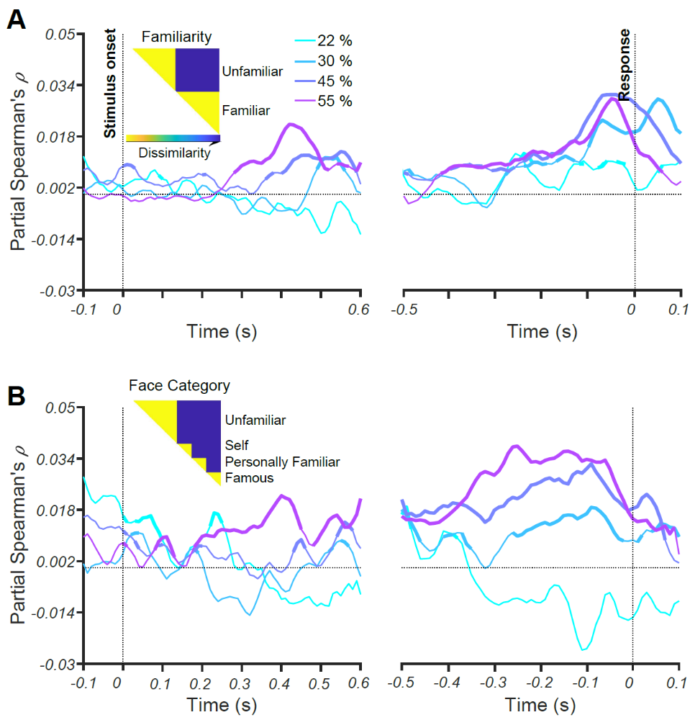
Supplementary Figure 1. Representations of face familiarity and categories revealed by RSA. Time course of Spearman’s correlations between neural RDMs and model RDM (shown as insets) for (A) face familiarity; and (B) face categories, unfamiliar, famous, self and personally familiar faces, before partialling out contributions from low-level features (see Methods). Each colored trace shows the correlations over time for one phase coherence level. Thickened lines indicate time points where the correlation is significant (sign permutation test, FDR-corrected significance level at p < 0.05), and black horizontal dotted lines indicate 0 correlation. The left panels show the results for stimulus aligned trials while the right panels represent the results for response-aligned trials. Note that the correlation values are higher compared to the results after partialling out contributions from low-level features (see Figure 4).

http://mmlab.ie.cuhk.edu.hk/projects/CelebA.html https://megapixels.cc/datasets/msceleb/
https://github.com/Masoud-Ghodrati/face_familiarity

